**Q. Execute OVER and PARTITION BY Clause in SQL Queries.**

Ans.

The PARTITION BY clause is used to divide the result set into partitions to which the window function is applied separately.

It is commonly used with aggregate functions to calculate values within each partition.

The OVER clause is used to define the window or set of rows on which a window function operates.It specifies the partitioning and ordering of the result set for the window function.

The syntax is OVER (PARTITION BY column1, column2, ... ORDER BY column3, column4, ...).

If we don't use PARTITION BY in the OVER clause, the window function operates on the entire result set.

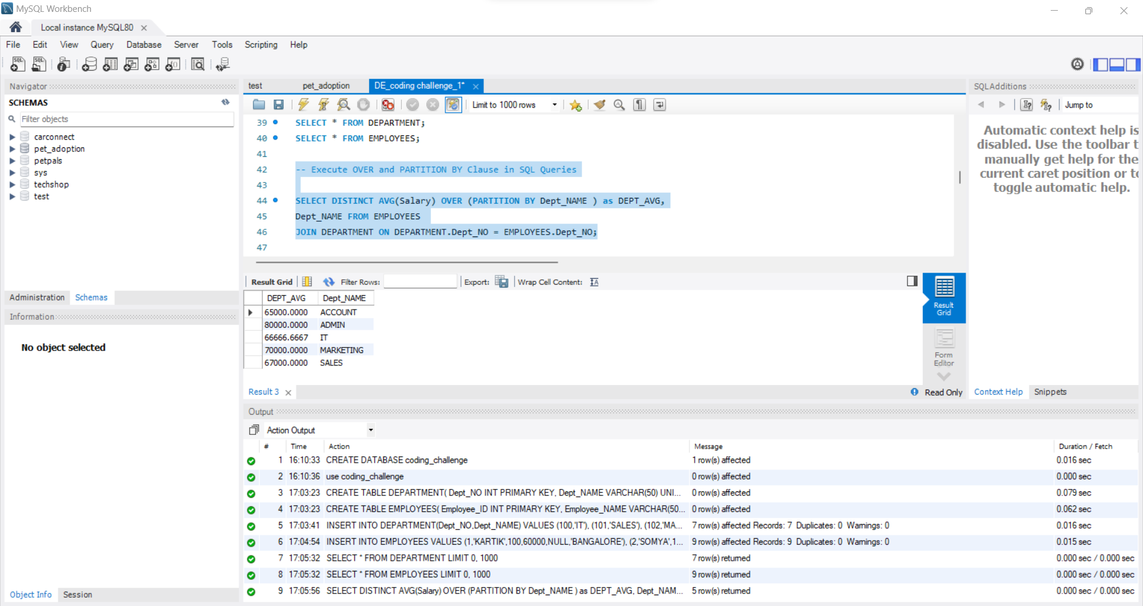

**Q. Creating subtotals & Total Aggregations using SQL Queries.**

Ans.

Subtotals and total aggregations are concepts related to summarizing and analyzing data in a database. They are often used in reporting and analytics to provide a concise summary of information.In SQL, these concepts are often implemented using the GROUP BY clause for subtotals and aggregate functions like SUM, COUNT, AVG, etc., for total aggregations. Additionally, the WITH ROLLUP clause is sometimes used to generate subtotals and a grand total in a single query.

The ROLLUP clause is used in conjunction with the GROUP BY clause to generate subtotals and a grand total in a single query.

